**Investment Update**

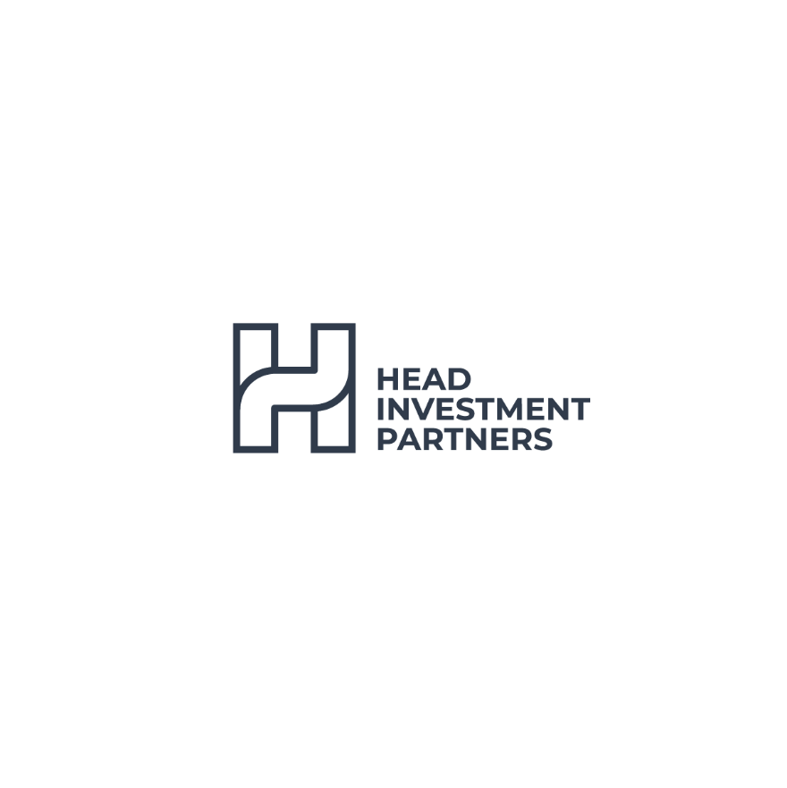

# **Q2: THe Melt-UP continues**

***Skepticism, anxiety, uneasiness, and doubt…the foundational principles of the first half of 2023’s rally.*** This YTD rally isn’t like many of the past, driven by greed, speculation, and exuberance. Instead, equity markets outperformed despite all the negativities. They exceeded the expectations of most Wall Street “experts.”

That isn’t to say the concerns aren’t warranted, but rather that that the markets were able to look past them so far in ’23. Prior to June’s “widening out” of the rally, more than 85% of the upswing of the S&P 500 was tied to 7 stocks posting enormous gains.

Let’s begin with first half performance and then work backwards a bit:

* S&P 500: +16.9%
* Russell 2000: +8.1%
* Bloomberg Agg Bond Index: +2.1%
* TIPS (Treasury Inflation Protected Sec): +1.9%
* MSCI EAFA (non-US): +9.9%

The US Federal Funds rate now reads 5.25%, its highest level since the Global Financial Crisis of 2008. Market participants were encouraged by the June pause in rates, but also generally expect 1-2 additional moves by the Fed in the back half of the year.

As John Maynard Keynes said nearly a century ago, ***“The Markets can remain irrational longer than you can remain solvent.”*** Said another way, one is wise not to try to speculate on short-term market behaviors because they often defy the odds. The consequences of being too pessimistic can be as detrimental as being too optimistic.

As we arrived at the halfway mark of 2023, there are rational reasons to remain cautious on the equity markets. Valuations are extended relative to history for many parts of the market. Headwinds in the economy (the Fed, tight labor, inflation among them) are not hard to identify even though the Fed almost refuses to acknowledge them. Another 1-2 rate increases are likely to further squeeze credit and drain liquidity from the system.

Heading into the second half, below is a quick highlight of selected assets and key data points we are using to drive our decisions:

* S&P 500: 19.1x forward P/E
* Nasdaq: 28x forward P/E
* Energy Sector: -5.5% YTD (3.7% yield is second to Real Estate for S&P 500)
* R1000 Value trades at .56x the valuation of R1000 Growth (15% discount to 25-year avg)
* May’s Consumer Confidence below 60 has historically signaled higher equity markets 12-mo later
* Profitable Small cap equities trade near their deepest discount to Large Cap peers since the GFC

As wise men of the industry have posited, bull markets rarely die of old age and valuation alone is never a reason to buy anything. Stay tuned for a second half likely full of more fireworks.

**Disciplined and focused…**

Watching a bit of NASCAR’s first ever road race on the streets of Chicago (after they received record rainfall earlier in the day), I was reminded of how focused we can be when challenges are presented. No longer was it just about navigating the 12-turn course…it was all of that **and** wet roads!

As the market defies logic and bounces higher on bad news, Fed hikes, and seemingly obscure data, it’s easy to be tempted to chase those moves. When large cap growth outpaces value by 24% YTD, one can feel foolish to own value. With technology +43% YTD, being overweight energy (-5.5% YTD) can seem painful.

Why do we own value? Why do we own energy? Why own non-US Equities when US Tech and AI are the leading headline to seemingly every news story?

Just like the driver focused on running his own race, we remain disciplined as we manage portfolios for our clients. Discipline can be a painful thing at times, but one that is seldom regretted. We own the above-listed segments of the markets as both components of a diversified portfolio and because we believe there is unlocked potential therein. Furthermore, these segments of the market, we believe, stand to be more resilient in the coming months than many of their “high flying” peers.

If we knew concretely that the economy wasn’t headed into a recession and that a new era of rapid economic expansion was at hand, our positioning would likely shift. But that’s a leap that few we represent and few experts we respect are ready to make!

**What does that mean?**

Quality, resilience, cash flow, and discipline are the keys components that underlie our client portfolios as we enter the second half. Should the first half be duplicated, we want to meaningfully participate. If a rockier ride lies ahead, we want to weather the storms and reposition opportunistically through it.

**Challenges ahead…**

Below is the list of market headwinds we shared in the Q1 update. Only the Debt Ceiling is gone (for now). There’s little denying that the economic headlines will still lean negative for some time. At least half of economists expect the US to slip into a recession in late 2023 or early 2024.

* Tight Fed Policy
* Sticky Inflation
* Banking stresses
* China fears
* Russia/Ukraine
* Earnings slowdown & margin compression
* ~~US Debt Ceiling~~
* 2024 US Election

**Defensive Tools:** As we enter the back half of the year, many of our portfolios carry a portfolio yield of 3.5 - 4%, despite an allocation to fixed income of <50%. That is not accidental or coincidental! Our focus on cash flow and yield, we believe, will provide us with a healthy blend of resilience and participation as we move forward. Among key portfolio components entering the back half are the following:

* Covered Call ETFs
* ITM Covered positions
* Buffered ETFs
* Investment Grade Bond Portfolios
* Short-dated US Treasuries
* High cash-flow and dividend growing stocks

This positioning allows us flexibility, which we believe will be critical to navigating and succeeding in the coming quarters. What has been out of favor YTD, we believe, will once again present investors with a reward (think value, energy, small caps). In the meantime, by creating high cash flow, we allow the portfolio to continually dollar-cost-average into high quality positions over time.

If history is any indication, it’s better to consistently buy than to try to time when you buy. Quality rarely stays out of favor long and deep discounts are often resolved by higher prices. Sector biases and political beliefs can often cloud one’s judgment; we believe there’s benefit to objectivity and patience as we enter the second half of 2023. There’s a chance it looks like the first half, but that chance isn’t one we’d wager on aggressively.

**BOnds TOday: risks and opportunities**

With a meaningfully inverted yield curve, bond investors now face a dilemma as challenging as any in the last 50 years. To help explain today’s dilemma and how to position for the years ahead, we begin by laying out an overview of the range of risks faced by bond investors:

**Credit Risk:** Bonds issuers run the gamut, from the US Government and its agencies, to small foreign, state, and local governments. From major AAA-rated corporations to companies challenged for survival. Each bond strategy carries a level or risk associated with the creditworthiness (and collateral) backing their promise to meet their obligations. Under “normal” circumstances, there is a premium yield attributable to those of lower creditworthiness. During stressful times, that premium associated with a bond’s credit (known in the industry as “spread”) increases to account for a collectively decreased risk appetite.

**Liquidity Risk:** while this one seldom comes up in client conversations, it is important in the marketplace. US Treasuries have nearly no liquidity risk and trade very efficiently, as do most parts of the bond marketplace with whom investors are familiar. There are, however, segments of the market often associated with leveraged buyout deals where there’s lower liquidity exchanged for higher yields. At present we have elected not to participate actively in this space, but it is a $1 Trillion plus market (about the same at cryptocurrency, for point of reference). As the name suggests, these strategies typically come with quarterly liquidity (or worse).

**Reinvestment Risk:** This is a very real risk for short-term bond owners today. This is the risk that, when a security matures, one cannot replace it with a similar bond at a similar yield. For example, a 12-month Treasury may yield over 5% today, but in a year may yield 3.5%. In that example, the risk is that one must settle for a lower yield (or revise what type of security he is willing to own) in 12 months.

**Duration Risk:** This risk, most referenced for a bond portfolio, mutual fund, or ETF, describes the interest rate sensitivity of a bond strategy. It’s also the most misunderstood among the ones listed. For point of reference the Bloomberg Aggregate Bond Index (AGG) has a duration of 6.3 Years. In 2022, having a duration of 6.3 years meant significant losses for investors as the Federal Reserve raised rates aggressively. The inverse holds when the Fed starts to cut rates.

What duration signifies is the expected impact of a 1% move in the Fed Funds Rate on a portfolio. In the example of the AGG, a 1% move higher in rates would imply a -6.3% drop in the price of the bonds. Conversely, a 1% cut in rates would indicate a +6.3% increase in bond prices. In each example, the underlying yield of the portfolio adds to price move of the bonds to calculate total return. For the AGG, a 3% yield would leave investors -3.3% with a 1% rate increase across a year or a +9.3% return in a year where rates fell 1%.

As you can see, the larger the duration figure, the greater the potential swing in the prices of a bond portfolio based on duration alone.

**What to do:** As we look to the horizon, the question becomes how to navigate the elements of risk listed to optimize one’s exposure to bonds for the coming 1-2 years. For context, a 1-year Treasury yields well over 5.3%, a typical Investment Grade Bond portfolio of duration of 2.5-3 years yields 6-7%, High Yield bonds boasts a yield over 9% in many cases, and index-duration strategies generally carry a yield lower than the 1-year Treasury. It’s an unusual lay of the land, as we mentioned at the beginning.

For many, the temptation has been to load up on short-term Treasury positions and have complete confidence in the outcome for the next calendar year. But what if rates fall because of economic stress and a Fed response? High Yield gives a 3-4% “pick-up” in yield and a duration below the AGG, but introduces credit risk at a time the economy appears to be slowing.

Our viewpoint is that an investor who is tilted toward very short duration is wise to begin lengthening duration now. We are not suggesting a full AGG duration of 6.3 years, but a gradual move from <1 year to the 3-4 year average. This would allow for the potential of total return **when** rates fall (the Fed projects this in late 2024 but have been more wrong than right on timing) and a reduction of the risk associated with reinvestment. Furthermore, we believe selective exposure with active managers in credit is still appropriate, especially in the IG Corporate, BB High Yield and US Mortgage spaces.

It is our estimation (and an opinion shared by many) that a properly aligned fixed income portfolio could reasonably produce a total return of 7-9% per annum over the next 2-3 years. There are many variables that could affect that viewpoint, but we believe that possibility is real and one investors should consider when balancing the allocation to fixed vs. equities between now and the 2024 election. Bonds again “sport yield” and investors are wise to position accordingly before the window to do so has passed them by. We cannot time this allocation but believe it’s fair to say we are closer to the end of the Fed’s hiking cycle than its beginning, thus a gradual lengthening of duration is appropriate.

# **IMPORTANT ANNOUNCEMENTS…**

* The transition from TD to Schwab is coming Labor Day weekend. Over the coming weeks you will receive multiple communications regarding this transition. Some will likely be confusing and raise questions. **Please call us at any time to discuss!**
* Your account will move automatically to Schwab (no signatures required), as will all attached permissions that allow our team to manage your accounts, move money, etc. **Your relationship with Head Investment Partners is not affected in any way!**
* You will be assigned a new account and need to log into a new website in the coming weeks to continue access to the account on-line. We can help you through this process if you encounter any issues.
* Once the transition happens, we encourage all clients to log-in to review their accounts. If you see anything that looks “off” please contact us and we will immediately investigate it.
* We are excited about this new partnership with Schwab. It will bring additional technologies, new research capabilities, and an even better client interface. Stay tuned!

# **Smoky Mountain Service Dogs golf OUting…**

As you can tell, a lot of fun was had by all…and the organization raised meaningful funds to help support their efforts to match veterans with essential support animals.

*Past performance is not a guarantee of future results. Securities offered through* ***Triad Advisors, LLC*** *(****Triad****) member FINRA/SIPC. Investment Advisory services offered through* ***Osaic Advisory Services, LLC*** *(****Osaic Advisory****).* ***Triad*** *and* ***Osaic Advisory*** *are separately owned and other entities and/or marketing names, products or services referenced here are independent of* ***Triad*** *and* ***Osaic Advisory****.*

|  |  |  |
| --- | --- | --- |
| Head Investment Partners  2280 Valley Vista Road  Knoxville, TN 37932  865-999-5332 |www.headinvestmentpartners.com | | |
|  | | |
|  |  |  |
|  | | |
|  |  | |